CS 550 Final Project Report

Sun-Earth-Moon-Mars System

Xiaoru Chen

[chenxia2@oregonstate.edu](mailto:chenxia2@oregonstate.edu)

**Proposal:**

**Introduction:**

The goal of this project is to create a Sun-Earth-Moon System.

**Requirement:**

* It involves 2D computer graphics - the orbits of the planets.
* It involves four 3D computer graphics (spheres of Earth, Moon, Mars, and Sun).
* It involves textures for all four 3D computer graphics.
* It involves lighting from the Sun.
* Centered on the sun, the earth and Mars goes around the sun and rotates on their axis.
* The moon goes around the earth and turns on its own axis.
* The speed of revolution and rotation will be accelerated to the point where it is visible to the naked eyes.
* The radius of the sun would be reduced to a tenth of its actual size.
* Will scale the orbital periods.
* Treat orbits as circular.
* Good outside viewing so that viewers can see everything at the beginning.
* Point-light lighting from the Sun.
* One viewing option, watching the moon’s animation only. (Since the Sun may be too big and too close).

**What I actually did for my project, with images:**

I created three 2-D computer graphics - the orbits of the planets.

I created four 3D computer graphics (spheres of Earth, Moon, Mars, and Sun).

I created textures for all four 3D computer graphics.

I created a point light from the Sun.

The radius of the sun has been reduced to 1/50 of its actual size. (Scaled by 1/50).

It should be 109 times bigger than the Earth, however, in this project, it is 2 times bigger than the Earth.

The size of the moon is 1/3 of the size of the Earth.

The size of the Mars is ½ of the size of the Earth.

Orbital Period is proportional to (Orbital Radius) ^(3/2).

EarthOrbitalRadius = pow(EarthOrbitalPeriod, 2./3.) / 2.

MarsOrbitalRadius = pow(MarsOrbitalPeriod, 2./3.) / 2.

MoonOrbitalRadius = pow(MoonOrbitalPeriod, 2./3.) / 2.

Orbits are circular.

I set a good outside viewing so that viewers can see everything at the beginning.

I created Key F, to freeze the animation, and I created Key 0 to turn on and off the point light from the Sun. Key I and Key M to switch viewing points.

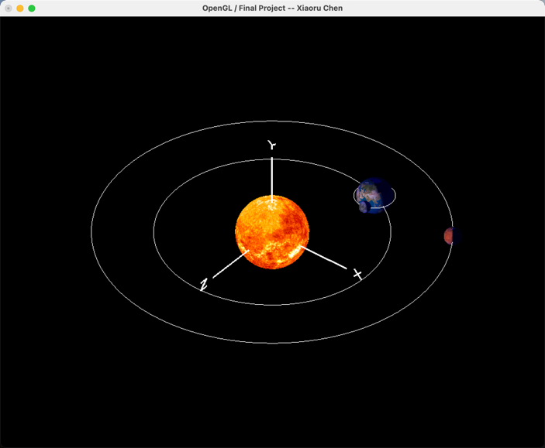

**Fig. 1 Sun-Earth-Moon-Mars.**

**How is my project differs from what I proposed, and why.**

First, I reduced the size of the sun from one-tenth to one-fiftieth of its actually size compared with the other planets. Because in order to be able to show all the planets at the same time. If the sun is too big, we can't see the Earth, the moon, and Mars.

I created Key F, to freeze the animation, and I created Key 0 to turn on and off the point light from the Sun. I did it because it is easy for debug.

Third, I changed the dynamic view of a point on the earth to a fixed view on the sun. Because of the cost of time, the coordinates of gluLookAt for the dynamic view are not calculated. The rotation perspective takes into account both the earth's revolution and rotation.

In addition, I added another viewing point, the eye position is following the Mars position, and we are watching the whole system from a different angle.

**Any impressive cleverness I want you to know about**

I used the actual earth, moon, and Mars orbital periods, such as earth's orbital period is 365 days, and Mars' orbital period is 687 days, and the Moon’s orbital period is 27 days. Such a setting, basically in line with the actual operation law. The Earth goes around the sun once, the moon goes around the Earth about 12 or 13 times, and Mars is about halfway around.

**What I learned from doing this project (i.e., what I know now that I didn't know when I started).**

First of all, I learned that the speed of the moon's orbit around the Earth could easily be set very fast because of its short orbital radius.

Also, I found it very difficult to dynamically adjust the view using gluLookAt, taking into account both the rotation and revolution of the Earth. Even using the sine and cosine formulas to adjust the x and z coordinates of the viewing point, it's hard to synchronize the view with the Earth in the first place. Although the viewing point could remain relatively stationary with the Earth, this causes a deviation from the earth's position.

**Some images that are especially representative of what I did:**

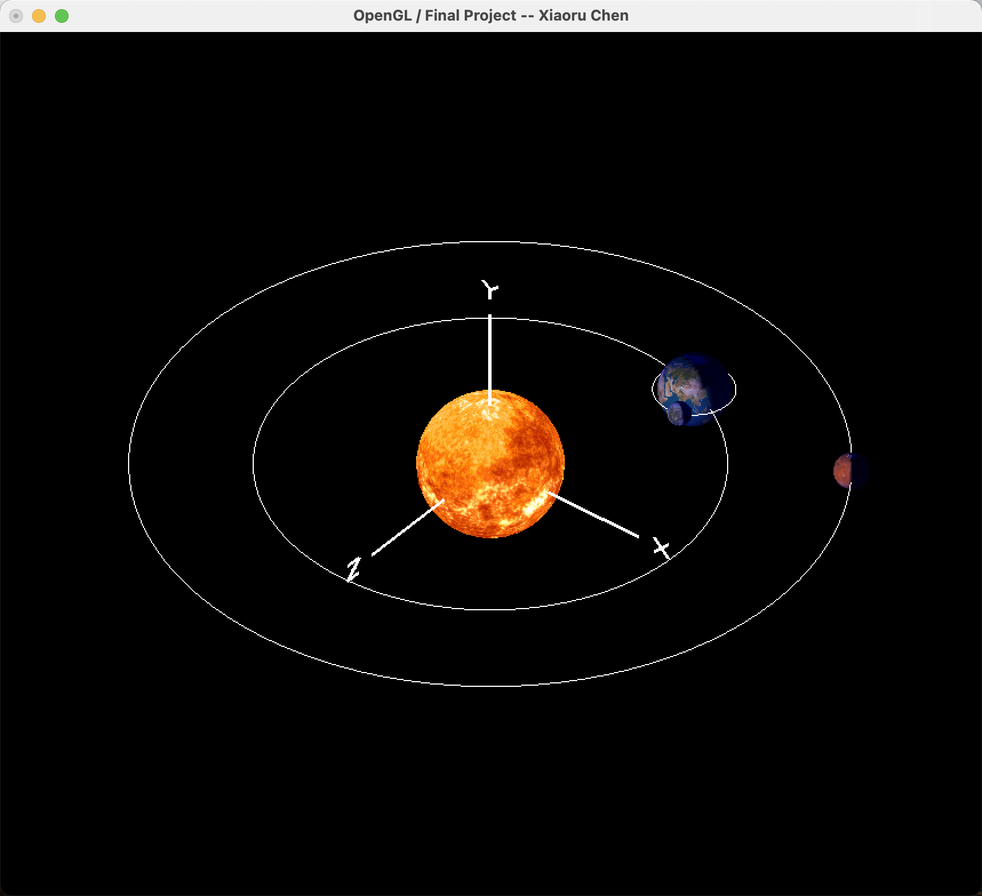

**Fig. 2 The whole system.**

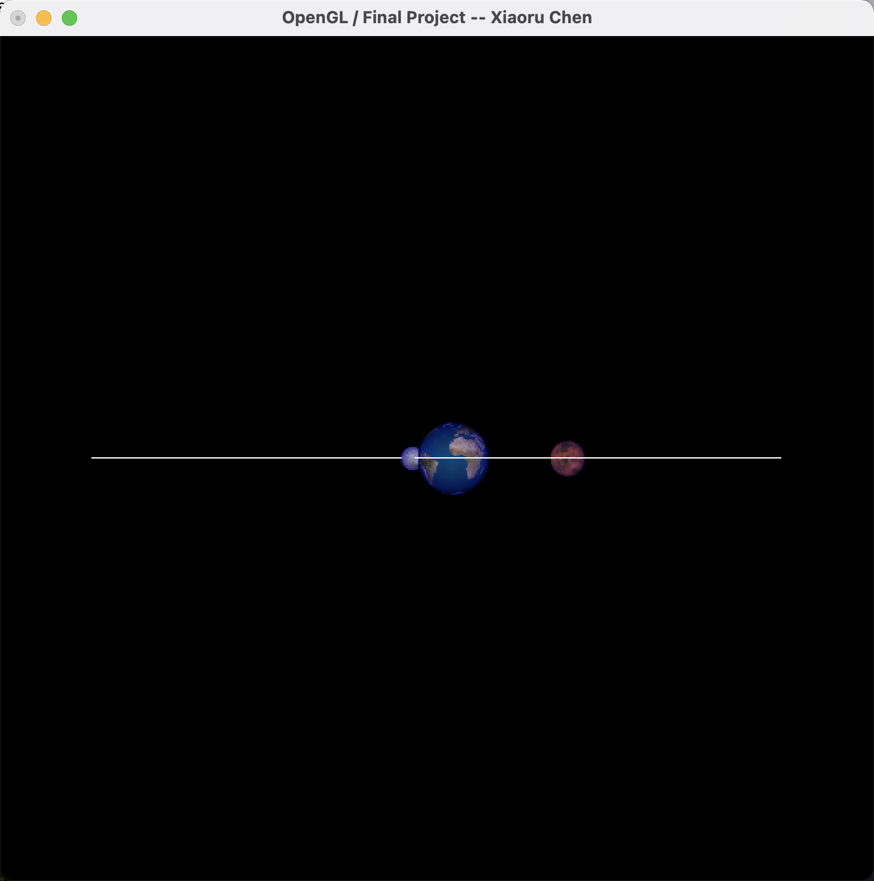

**Fig. 3 A viewing option where the eye is on the Sun, looking the earth, Mars and moon pass by.**

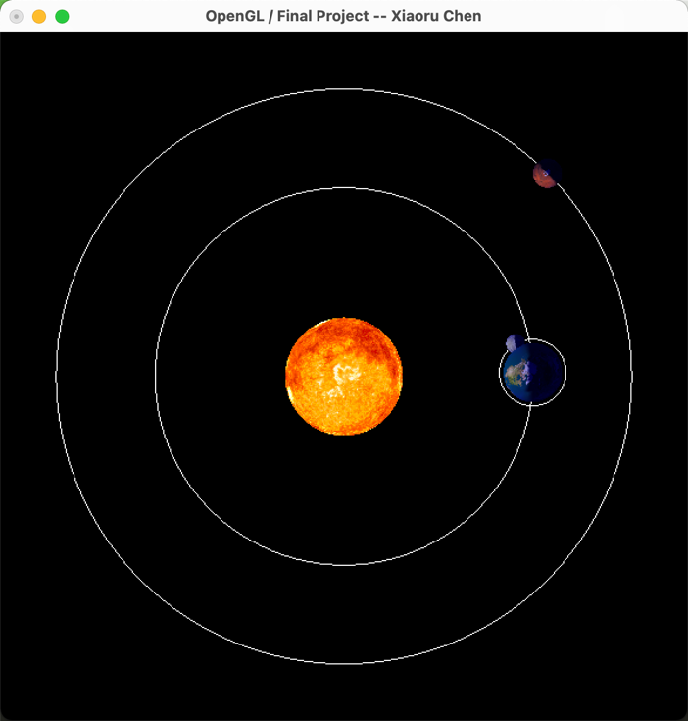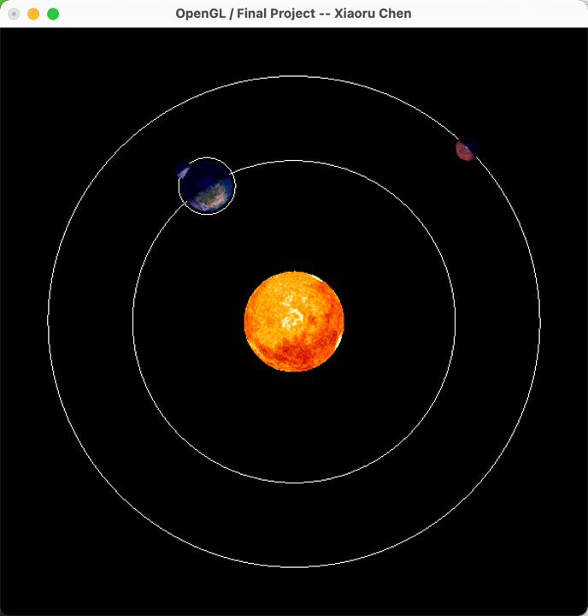

**Fig. 4 A viewing point where the eye is following the Mars, looking at the origin.**

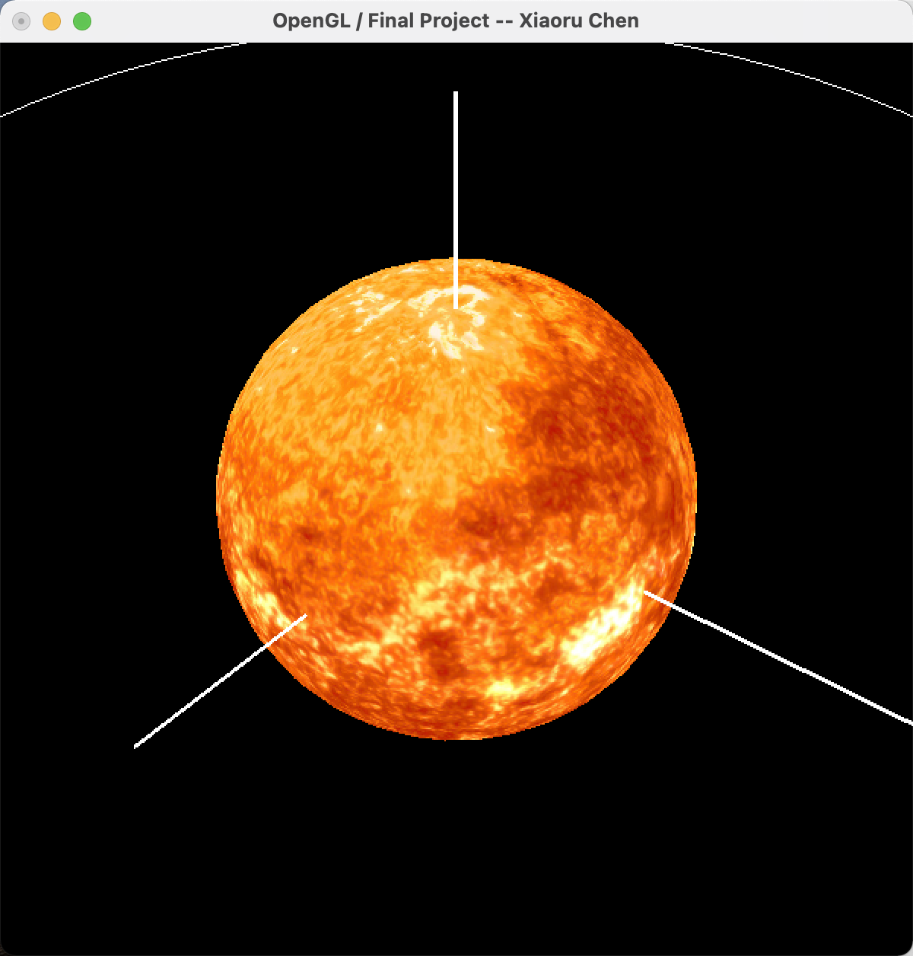s

**Fig. 5 The sun with texture is placed at the center of the coordinates.**

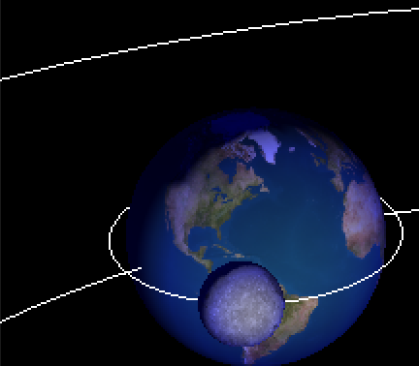

**Fig 6. The earth and Sun in orbits.**

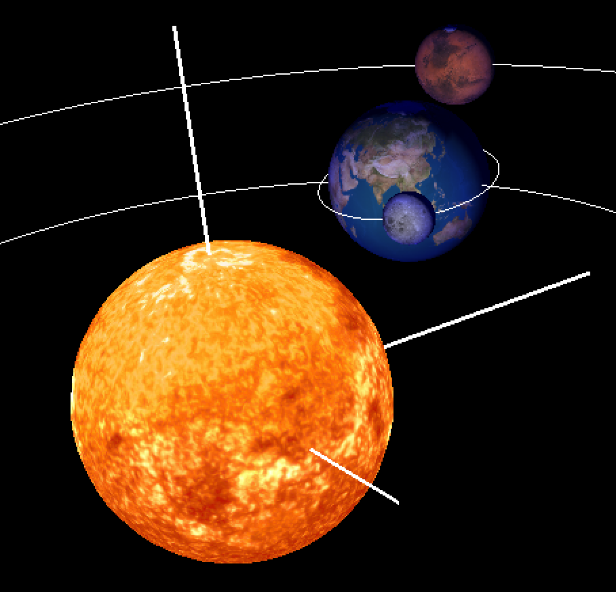

**Fig. 7 Mars moves according to Kepler's Third law at the far end of the frame.**

**All planets move according to Kepler's third law.**

**A link to the project video:**

<https://media.oregonstate.edu/media/t/1_aw2g3zj2>